 |  | Technical Specification  Yard Management System  for  Plate Mill yARD,  Jindal Steel & Power Limited,  Angul, odisha  (Ref No - 26/JSPL/PMYMS/v0)  23rd Jan 2026 Ver. 0  Hitachi India Pvt Ltd.  www.hitachi.co.in | sales.paeg@hitachi.co.in

REVISION HISTORY:

Sr. No. | Revised By | Checked By | Approved By  (QMS) | Details | Date | Rev No.
1 | S. Randive / M. Pant | M. Patil | V. Tiwari | First issue | 23-01-2026 | 0

Copyright © 2026 Hitachi India Pvt. Ltd.
All rights in this work are strictly reserved by the producer and the owner. Any unauthorized use of this material—including, but not limited to, copying, reproduction, hiring, lending, public performance, broadcasting (including communication to the public or via the internet), or transmission by any distribution or diffusion service, whether in whole or in part—is strictly prohibited. Unauthorized use may constitute a violation of applicable copyright laws and may result in civil and/or criminal liability. This work contains confidential and/or proprietary information. The information and ideas contained herein are provided solely for the use of the intended recipient. All content remains the exclusive property of Hitachi India and may not be disclosed, shared, or communicated to any third party, in any form or by any means, without prior written authorization.

TABLE OF CONTENTS
1. EXECUTIVE SUMMARY 5
2. GENERAL OVERVIEW 7
2.1 INTRODUCTION 7
2.2 ABBREVIATIONS USED 8
2.3 PROCESS FLOW 8
2.4 OVERVIEW OF PMYMS 12
3. OFFERINGS 16
3.1 DESIGN SCOPE OF WORK 16
3.1.1 End-to-End Material Traceability 16
3.1.2 Smart Yard Management 17
3.1.3 Real-Time Communication and Action Handling 18
3.1.4 Graphical 2D & 3D Yard Visualization 18
3.1.5 Rule-Based Dynamic Stacking and Space Optimization 19
3.1.6 Stacking Rule Simulation and Validation 20
3.1.7 Automated Crane Instruction and Movement Integration 20
3.1.8 Load-Based Multi-Material Handling Recognition 21
3.1.9 Manual Intervention and Exception Handling 21
3.1.10 Logistics and Movement Planning Management 21
3.1.11 Operation History and Event Log Management 22
3.1.12 Tools for Easy Troubleshooting and Debugging 22
3.1.13 Smart Reporting System and Dashboards 22
3.1.14 Role-Based Access and Security Management 24
3.1.15 Scalability and Future Expansion Readiness 24
3.2 REMOTE SUPPORT SYSTEM 25
3.3 DOCUMENTATION CONTROL 25
3.4 CUSTOMER TRAINING 25
3.5 SYSTEM CONFIGURATION (FOR REFERENCE) 26
4. TECHNOLOGY STACK 27
5. SCHEDULE 30
6. SCOPE OF SUPPLY 33
6.1 SCOPE OF SUPPLY DEFINITIONS 33
6.2 DIVISION OF ENGINEERING, SOFTWARE DEVELOPMENT, & ERECTION/COMMISSIONING SERVICES 34
6.3 VALUE ADDITION 36
6.4 WORK COMPLETION CERTIFICATE 36
6.5 BUYER OBLIGATIONS 37
6.6 EXCLUSION LIST 38
6.7 BUYER PREREQUISITES: 39
6.8 BINDING CONDITIONS: 39
6.9 CYBERSECURITY DISCLAIMER 41
7. DISCLAIMER 42
7.1 SOFTWARE LICENSES 42
7.2 CHANGES DUE TO TECHNICAL IMPROVEMENTS 42
7.3 CONFIDENTIALITY OF INFORMATION (Non-Disclosure Agreement) 42
7.4 LIMITATION OF LIABILITY & CONSEQUENTIAL DAMAGES 42
8. COMPLIMENTRY PROOF OF CONCEPTS (PoC) 44

EXECUTIVE SUMMARY

Hitachi India Pvt. Ltd. (hereafter also referred to as HIL) provides automation solutions and digital solutions designed and developed for the industrial sector, particularly the metals industry. It takes advantage of more than 105 years of OT (Operation Technology) experience with process knowledge experts & SMEs and 55+ years of IT experience with the newest automation technology.
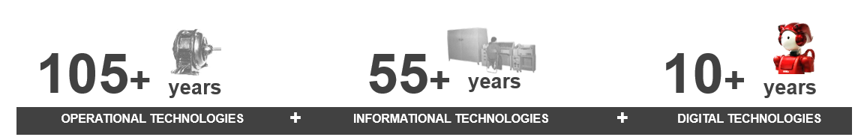
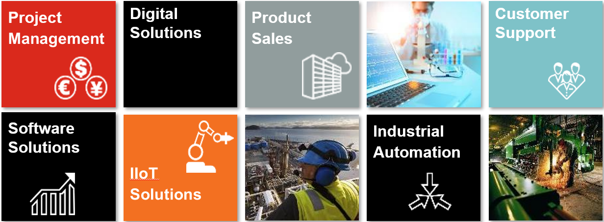

SELLER is uniquely qualiﬁed to provide the control system and digital solutions you desire due to our in-house team of well-trained and certiﬁed professionals with the right experience & knowledge in designing, developing, and deploying the best solutions possible over a wide range of sectors & areas.

Some of our clients include:
 |  | 
 |  | 


GENERAL OVERVIEW

INTRODUCTION
This document is a technical proposal for Design, Engineering, Supply and Commissioning of Slab & Plate Yard Management System, Jindal Steel and Power Ltd. (JSPL), Angul, Odisha. This Proposal is in response to the email enquiry request from JSPL, dated 8th Jan 2026 and subsequent discussions with the Subject: “Requirement of Yard Management Solution for Plate Mill at Jindal Steel, Angul”.

Hitachi India Pvt. Ltd. (hereafter SELLER) is pleased to submit this Plate Mill Yard Management System (PMYMS) technical proposal for Plate Mill at JSPL, Angul (hereafter BUYER).
SELLER is offering a solution that we are confident meets BUYER’s requirements and will bring significant value for Plant Managers. It also sets the stage for a phased Digitalization, IT & business process maturity program, AI based projects, Centralised Plant Dashboard which aims at bringing alignment across the business & manufacturing processes.
PROJECT DEVELOPMENT STAGES

ENGINEERING SURVEY
ENGINEERING REVIEW MEETING
DESIGN & BUILD
PRE-COMMISSIONING
COMMISSIONING
& LAUNCH



ABBREVIATIONS USED
Sr. No. | Abbreviation | Full Form / Description
1 | JSPL | Jindal Steel & Power Ltd.
2 | HIL | Hitachi India Pvt. Ltd.
3 | SV | Supervisor
4 | HMI | Human Machine Interface
5 | PLC | Programmable Logic Controller
6 | EOT | Electric Overhead Travelling Crane
7 | LT | Long Travel of EOT Crane
8 | CT | Cross Travel of EOT Crane
9 | L1 | Level-1 system
10 | L2 | Level-2 system
11 | L3 | Level-3 system
12 | PMYMS | Plate Mill Yard Management System
13 | HTC | Heat Treatment Complex

PROCESS FLOW
- Slabs are received in the slab yard and moved to the reheating furnace. The proposed system will log the material arrival and will send the tracking information with the Mill Level-2 system.
- Slabs exit the furnace and enter the roughing and finishing mills, where they are rolled into plates.
- Plates undergo cooling depending on grade and process route (HTC or Non-HTC). The proposed system will mark plates as “cooling in progress”.

The route distribution to HTC & Non-HTC will be as follows:
Sr. No. | Supply route | Distribution as in FY 24-25 | Expected Distribution with 1.2 MTPA
1 | Heat Treatment plates (HTC) | 16% | 45%
 | a. Furnace Normalized | 10%
 | b. Quench | 3%
 | c. Quenched and Tempered | 3%
2 | Non-HTC Plates | 84% | 55%
 | a. As rolled/Normalized Rolling | 76%
 | b. TMCP (Laminar Cooling) | 8%

- After QC inspection, both HTC and Non‑HTC plates are assigned to specific yard stack based on grade, thickness, customer order, or dispatch priority. The proposed system optimizes pile selection to minimize crane travel and avoid mixing incompatible materials.
- Plates are stored in Plate Mill Yard zones where cranes perform stacking and restacking operations following system-generated tasks. PMYMS maintains real‑time inventory position (zone → row → pile → layer).
- When customer orders are released, PMYMS generates a pick list and optimizes the crane dispatch sequence. The PMYMS system ensures correct plate identification using barcode/RFID/OCR (to be finalized during detail engineering).
- Plates are moved to the dispatch lane or truck/wagon loading bay, where loading alignment, weight compliance, and order matching are performed. PMYMS validates the correct plate-to-order mapping and records loading events.
- The PMYMS updates the final shipment record and closes the material movement loop.

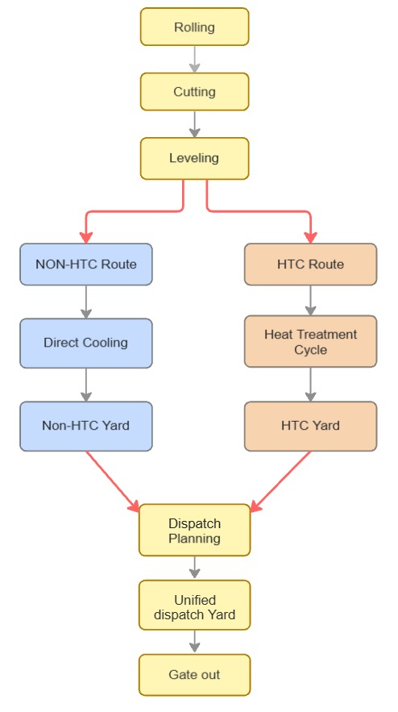

Existing Process for HTC:

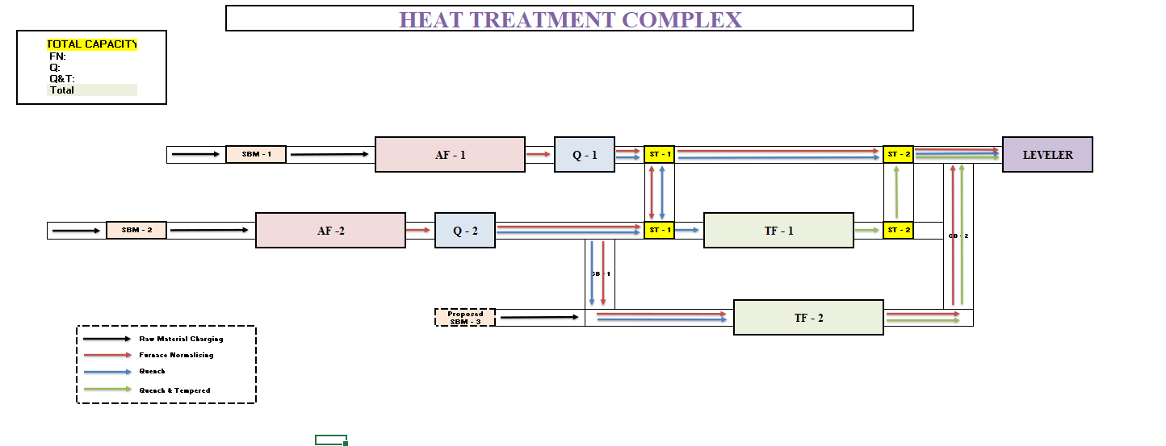

Note:
HTC (Heat Treatment Complex) operates through three primary processing routes:
- Furnace Normalizing (FN)
- Quenching (Q)
- Quenching & Tempering (Q&T)
For Q&T plates, the process includes an additional pass through the Tempering Furnace, which can be either TF1 or TF2, depending on availability and load.

OVERVIEW OF PMYMS
This proposal outlines the technical feature of Plate Mill Yard Management System (PMYMS) in a steel plant, where overhead cranes operate in manual mode. The PMYMS will provide real-time slab/plate location tracking, storage management, and slab/plate retrieval support, using position sensors installed on the cranes by BUYER.

System Objective:
- Ensure accurate tracking of plate position in the yard
- Avoid duplication, misplacement, or manual errors
- Provide operator and supervisor visibility of Yard
- Enable efficient slab/plate storage and retrieval operations
- Log crane movement and pick/drop events
- 2D/3D Yard Visualization
- Search & Locate Functionality
- Manual and Auto Override Options
- Simulation model for the following:
  - Stacking strategies
  - Yard utilization
  - Resource allocation

System Architecture:
- Crane Subsystem (BUYER Scope)
- Manually operated cranes
- Position sensors (X, Y axis) (not available now)
- Slab/Plate Lock/Unlock detection sensors (not available now)
- Gateway (not available now)
- Optional HMI for operator feedback (not available now)

b. PMYMS Server & Software:
- Digital yard map
- Input and Output material tracking
- Manual override and history logging
- API support

c. Yard Layout Configuration:
- Grid layout (zones, rows, columns)
- Configurable in software

Crane Hardware:
- Position Sensors: Laser Sensors for X and Y Coordinate Tracking
- Slab/Plate Lock/Unlock: Signal Feedback for Crane Tong
- PMYMS Server: Industrial Server (For Slab Yard & Plate Yard)
- Gateway: Hitachi Gateway for Integrating sensor data.
- Network: Wi-Fi or wired (to be discussed during detailed engineering)
- HMI

Note: All sensors will be chosen for working conditions for Plate Mill Area.

Integration:
- Plate Mill L2: Plate Production Data
- Furnace L2: Slab Tracking Data
- Plate Leveller L2: HTC & Non-HTC Production Data
- MES/ERP: Order data, Shipping Plan, etc.
- Cranes, Position and Lock/Unlock Feedback

Yard and Cranes to be considered:
Plate Yard Map details as provided by BUYER are as under.

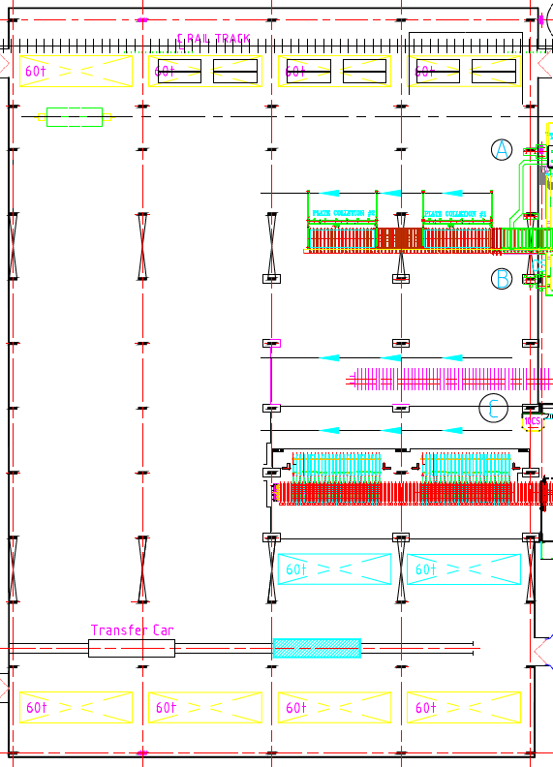
Fig: Plate Yard Area
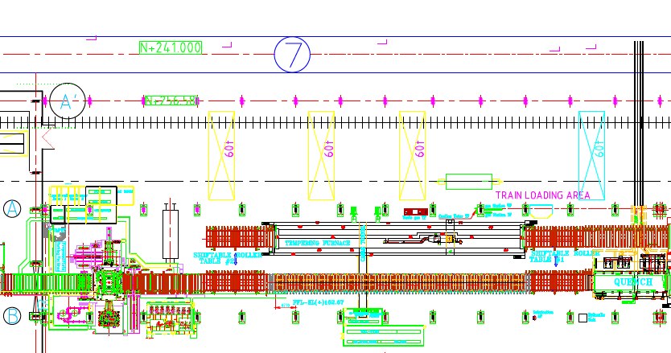
Fig: Train Loading Area

Crane Information:
Existing crane details as provided by the BUYER are as below.

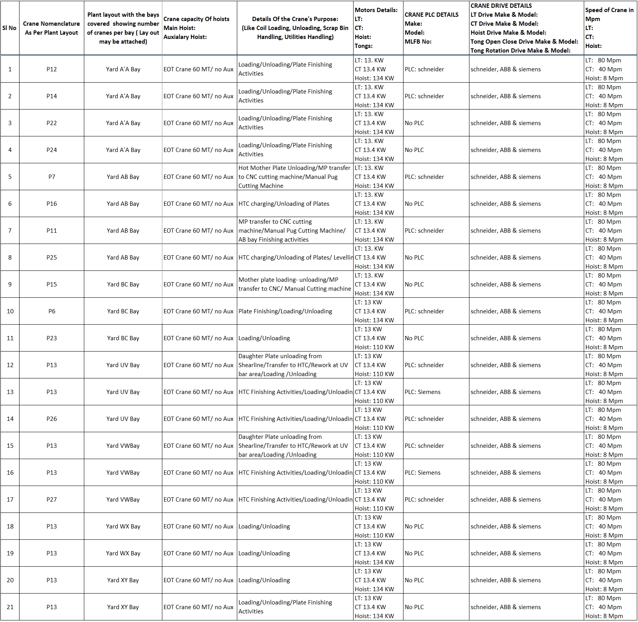

OFFERINGS

DESIGN SCOPE OF WORK
Implementation of Plate Mill Yard Management System (PMYMS) with Simulation Model for Plate Mill


End-to-End Material Traceability
PMYMS uniquely identifies and tracks material from receipt in the slab yard, through storage, movement, rolling, inspection, stacking, and final dispatch in plate yard. All events such as charging, kickbacks, pile changes, inspections, quality status updates, and shipping confirmations are recorded and linked with SAP and Level-2 systems, ensuring full auditability, compliance, and data reliability.
The Yard Management System ensures complete traceability of slabs and plates across entire lifecycle within the Plate Mill.

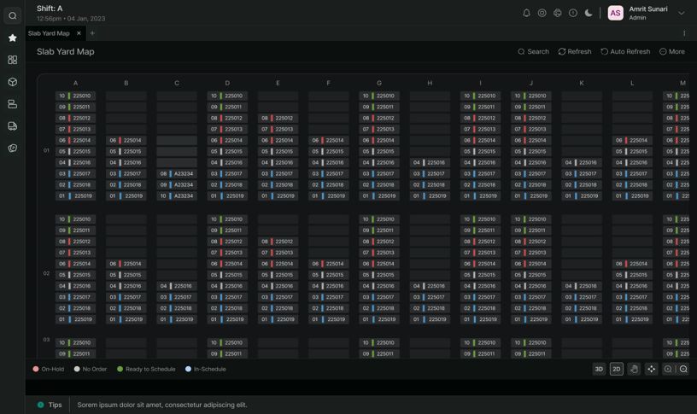
FOR REFERENCE
HIL CONFIDENTIAL


Smart Yard Management
PMYMS provides intelligent inventory control with real-time visibility and decision support. It maintains a live, synchronized digital representation of physical yard inventory.

The system evaluates yard stock based on material attributes such as grade, dimension, destination, quality status, and rolling or shipping plans. It supports optimized inventory utilization, reduces dead stock, minimizes rehandling, and enables proactive planning by aligning physical inventory with production and dispatch requirements.
All crane-wise work orders are logged & any slab and/or plate movement is reflected in the system, ensuring synchronization between physical yard conditions and system records. This eliminates stock mismatches, reduces manual reconciliation efforts, and improves confidence in inventory availability for operational and commercial planning.

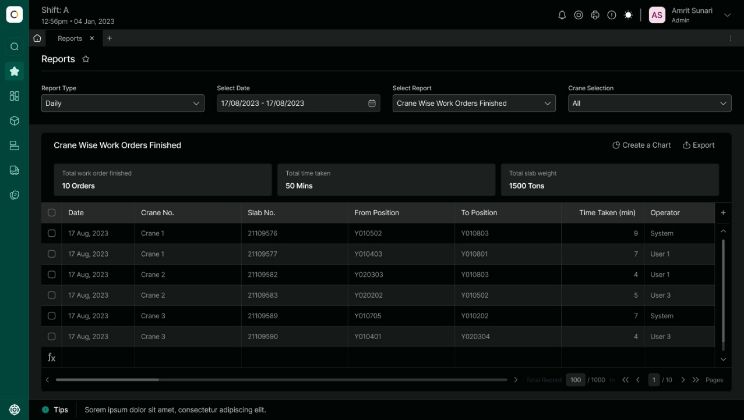
FOR REFERENCE
HIL CONFIDENTIAL


Real-Time Communication and Action Handling
The system enables real-time communication between SAP, Level-2, Weigher system and yard operations.
PMYMS exchanges data continuously with SAP and automation systems to receive rolling plans, charging instructions, quality status, and shipping details while sending back movement confirmations, stock updates, and loading memo information. This real-time data exchange enables immediate system-driven actions and faster operational response.
All telegrams (Inbound & Outbound) are logged in the system for easy troubleshooting & record-keeping.
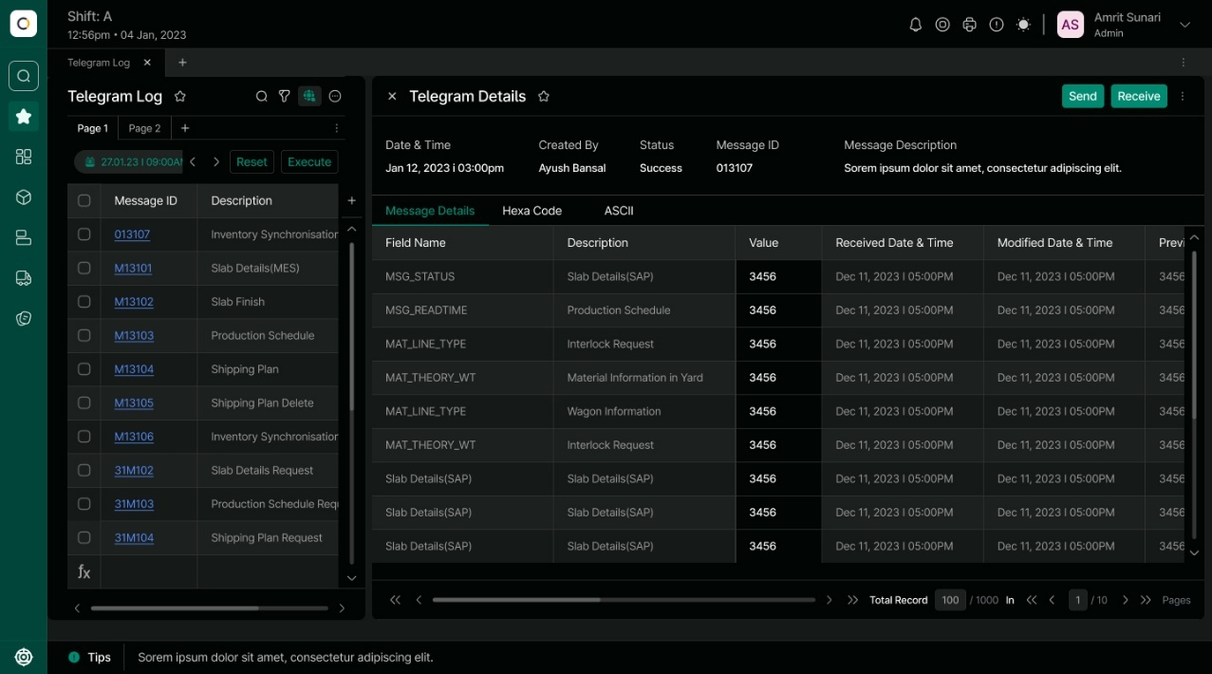
FOR REFERENCE
HIL CONFIDENTIAL


Graphical 2D & 3D Yard Visualization
PMYMS provides intuitive 2D and 3D graphical visualization of slab and plate yards.
The graphical yard interface displays real-time material positions, stack configurations, pile heights, crane locations, and yard occupancy. Users can search and filter materials by grade, reference, dimension, destination, or batch, significantly improving situational awareness and operational decision-making. The map provides multiple zoom levels and pan controls, enabling users to navigate efficiently to any area within the yard or facility.

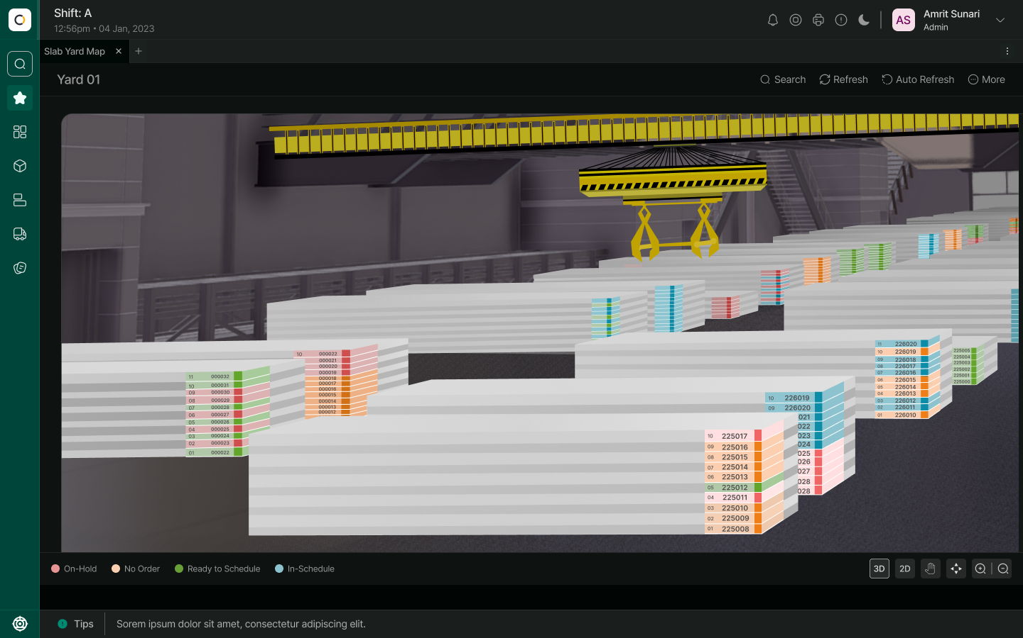
FOR REFERENCE
HIL CONFIDENTIAL

Rule-Based Dynamic Stacking and Space Optimization
The system dynamically recommends optimal stacking locations using configurable business rules.
PMYMS applies rule-based logic considering material properties, rolling or shipping plans, tolerance limits, and available yard space to recommend stacking locations. This minimizes pile changes, reduces unnecessary movements, and maximizes effective utilization of yard area while allowing easy modification of stacking rules as operational requirements evolve.


Stacking Rule Simulation and Validation
PMYMS allows simulation of stacking rules before execution.
The system can simulate stacking outcomes in real time based on defined rules and current yard conditions, enabling planners and operators to validate stacking strategies prior to execution. This reduces operational conflicts, avoids space constraints, and improves confidence in logistics planning.


Automated Crane Instruction and Movement Integration
PMYMS generates optimized crane movement instructions for automated and semi-automated operations.
Based on storage, transfer, or shipping requirements, PMYMS issues movement instructions to crane systems and display them on operator HMIs. Crane execution feedback is captured automatically to update material locations.
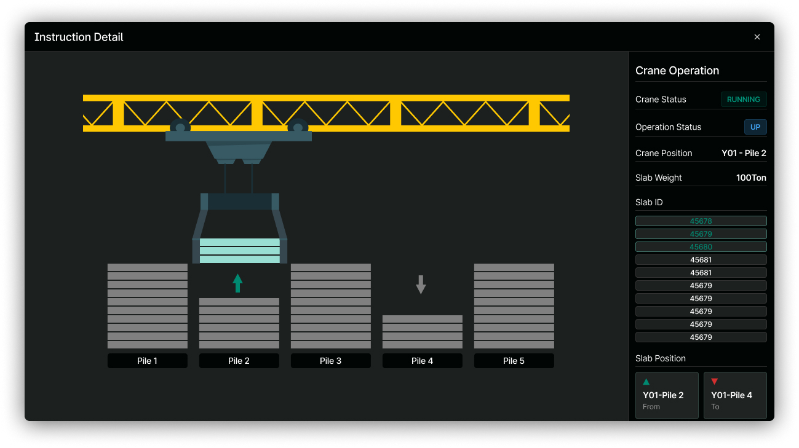
FOR REFERENCE
HIL CONFIDENTIAL


Load-Based Multi-Material Handling Recognition
The system supports tracking of multiple slabs or plates handled in a single crane lift.

Using load cell data, PMYMS identifies and validates multi-material lifts and accurately updates inventory and stacking information. This ensures correct tracking even during bulk handling operations, improving productivity without compromising traceability.


Manual Intervention and Exception Handling
PMYMS provides controlled manual intervention for handling operational exceptions.
Operators and supervisors can manually correct material locations, override system recommendations, or resolve mismatches when required. All such actions are logged with user credentials, timestamps, and reason codes to maintain data integrity and audit compliance.


Logistics and Movement Planning Management
PMYMS acts as the central logistics coordination layer for yard operations. PMYMS automates loading memo generation and dispatch execution.

The system manages slab entry plans, slab and plate transfer plans, shipping plans, and pile-change plans received from SAP. Confirmed plans are converted into executable yard and crane instructions, ensuring smooth and synchronized logistics execution.
Based on SAP shipping plans and wagon/truck details, PMYMS generates loading memos, issues loading instructions, tracks progress and confirms completion. It supports memo modification, cancellation, and stock restoration in case of truck/wagon unloading or reloading, with final data sent back to SAP


Operation History and Event Log Management
The system maintains a comprehensive operational event history.
Every material-related event—receipt, movement, stacking, inspection, adjustment, and dispatch—is stored with full contextual information. These logs support audits, performance analysis, and investigation of discrepancies or operational issues.


Tools for Easy Troubleshooting and Debugging
PMYMS includes built-in tools for rapid fault diagnosis and issue resolution.
The system provides message tracing, interface monitoring, event logs, and diagnostic views for MES/SAP, L2, Weigher and Crane communications. These tools reduce downtime by enabling faster identification and resolution of data or operational issues.


Smart Reporting System and Dashboards
PMYMS delivers intelligent reports and dashboards for operational and management insights.
The reporting framework provides real-time and historical reports on inventory, production, dispatch, logistics details, and yard utilization. Dashboards support drill-down analysis and customizable views to meet operational & managerial requirements.
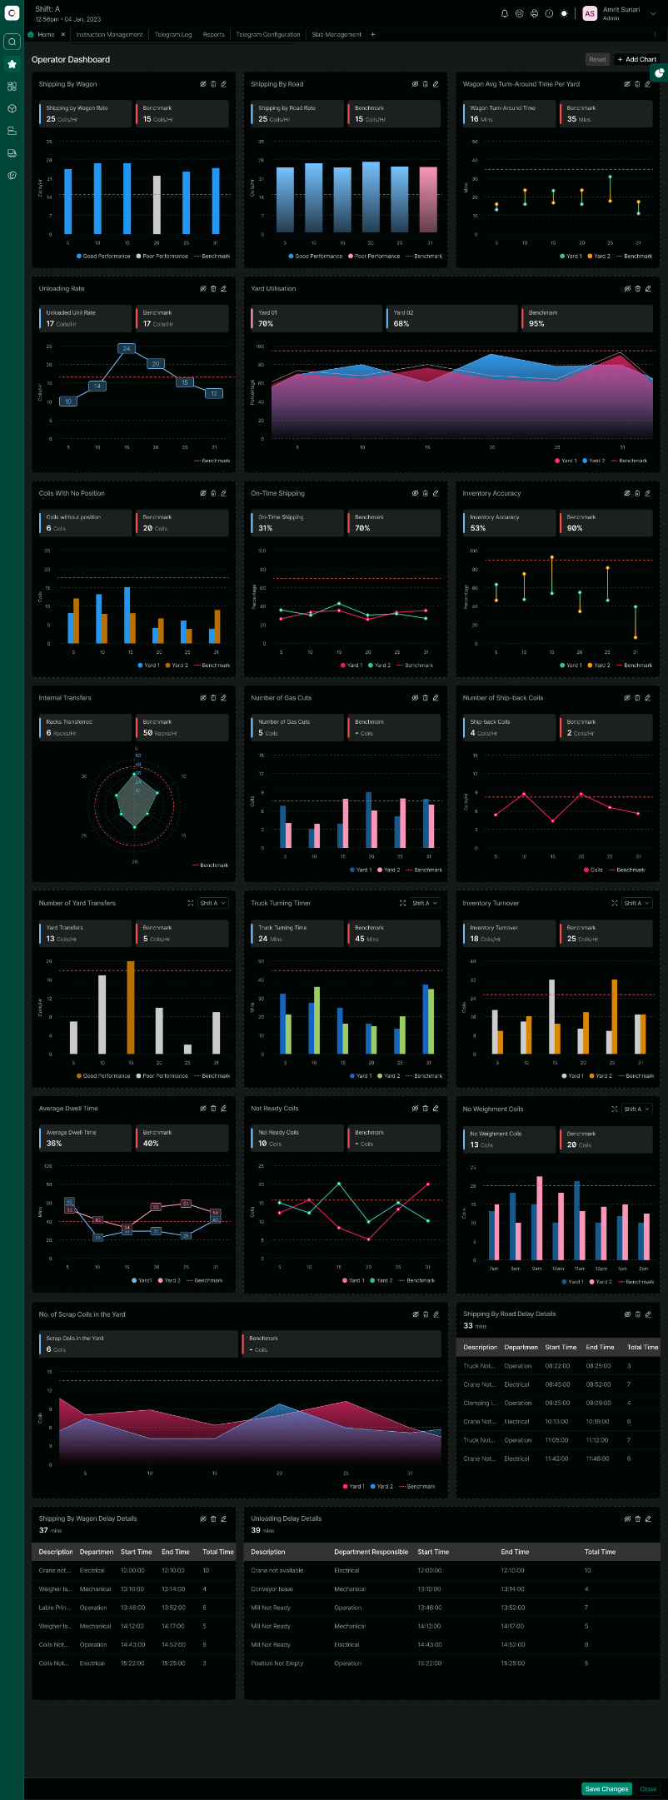
FOR REFERENCE
HIL CONFIDENTIAL


FOR REFERENCE
HIL CONFIDENTIAL


Role-Based Access and Security Management
The system enforces strict role-based access controls.
PMYMS restricts system access and functions based on user roles and responsibilities.
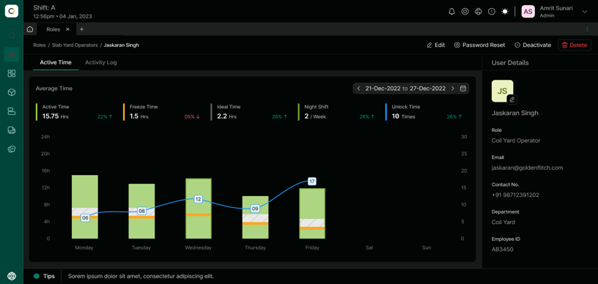
FOR REFERENCE
HIL CONFIDENTIAL


Scalability and Future Expansion Readiness
PMYMS is designed for scalability and long-term sustainability.
The modular and scalable architecture allows easy addition of new yards, bays, cranes, interfaces, and business rules. The system can accommodate future production increases and functional enhancements with minimal disruption.
NOTE:
The screenshots of PMYMS system (described above) are just for reference purposes. Please note that PMYMS system is fully customized and tailormade as per the site requirements and BUYER’s needs.

REMOTE SUPPORT SYSTEM
SELLER will provide complimentary remote maintenance support for troubleshooting and issue resolution (if any) for a period of 6 months from the date of completion of project. Necessary infrastructure and network configuration will have to be enabled by BUYER to facilitate this. Remote maintenance support will be limited to scope of supply of this proposal. Also, access to remote terminal should be made available to SELLER as per requirement. Dedicated Internet/Lease line at site to be arranged by BUYER.
The effective working hours at HIL Office shall be from 9:00 AM to 5:00 PM IST (Monday to Friday), excluding National Holidays.
NON-DISCLOSURE AGREEMENT (NDA) will be signed between BUYER and SELLER before starting the remote support.

DOCUMENTATION CONTROL
SELLER shall provide the following technical documentation of the complete PMYMS solution:
- Screen Design Document,
- Hardware Specifications,
- Software specifications, and
- Operation Manual

CUSTOMER TRAINING
SELLER shall provide training at site during commissioning to a maximum of 5 people for a maximum of 3 days. Training shall cover mutually agreed topics on PMYMS Web application supply. Training shall comprise of classroom training at site.

SYSTEM CONFIGURATION (FOR REFERENCE)
The reference system configuration of PMYMS is shown below:
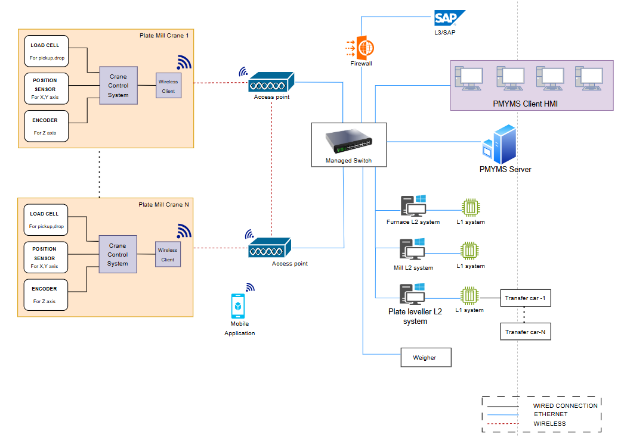
Note: The above architecture is provided for illustrative purposes only and is subject to modification during detailed engineering to optimize overall system performance and functionality


TECHNOLOGY STACK

The technology stack for various components is as follows:
Sr. No. | Components | Technology Used
1 | Application Front-end | Angular Framework.  Application can be viewed on a standard web browser like Chrome, Edge & Mozilla
2 | Database | MS SQL Server 2022 Standard Edition
3 | Application Back-end | Python Django
4 | Docker | For Deployment
5 | Mobile Application | Android Application
6 | Antivirus | Trend Micro or Equivalent

4.1 BASIC HARDWARE SPECIFICATIONS
Following is the list of Hardware required for PMYMS Application.

Sr. No. | Equipment Name | Specifications | Maker | Quantity  (Nos.)
1 | PMYMS Server  (Tower Based) | - INTEL XEON GOLD 5317 or Equivalent  - 12 Cores  - 64 GB RAM  - 2 TB Memory | HPE/ Dell/ Lenovo or Equivalent | 2  (Online & Backup)
2 | PMYMS Server Console & accessories | 23.8"FHD (1920x1080) resolution monitor with USB Mouse and Keyboard | HP/ Dell/ Lenovo or Equivalent | 2
3 | GSM Modem | 2G/3G/4G Industrial Cellular GSM Model with Ethernet Port & 2dBi Antenna 2mtr cable | Dynalog Or equivalent | 1 set
4 | HX Controller | For Unified Gateway | Hitachi | 1 set
5 | PMYMS Client Desktop | Intel core i5 Processor  16 GB RAM  512 GB HDD | HP/ Dell/ Lenovo or Equivalent | 4 set
6 | PMYMS Client Console & accessories | 23.8"FHD (1920x1080) resolution monitor with USB Mouse and Keyboard | HP/ Dell/ Lenovo or Equivalent | 4 Set

4.2 BASIC SOFTWARE SPECIFICATION
Below are the Software Specifications for the Proposed PMYMS system.

Sr. No. | Equipment/Software Name | Maker | Quantity (Nos.)
1 | Windows Server 2022 Standard OS(64 bit)  (5 CAL) | Microsoft | 2
2 | Windows 11 Pro OS | Microsoft | 4
3 | Microsoft Office 2021 | Microsoft | 6
4 | MS SQL Server 2022 Standard Edition  (5 CAL) / Other | Microsoft/ Other | 2
5 | Antivirus Software | Trend Micro | 6
6 | Python | - | 2
7 | Django Framework | - | 2
8 | Angular Framework | - | 2
9 | Backup Software for PMYMS Server | Acronis | 2

4.3 THIRD PARTY SOFTWARE REQUIREMENTS
Database: PMYMS system shall use MS SQL Server 2022 Standard Edition OR other suitable database. Decision regarding selection of database is solely decided by SELLER.
Remote Link: To provide a suitable level of response to operation & process execution problems and queries raised on site, SELLER requires a network connection via broadband / VPN to be established between SELLER and the BUYER’s site. Set-up and maintenance of this link will always be under the BUYER’s authority.

SCHEDULE

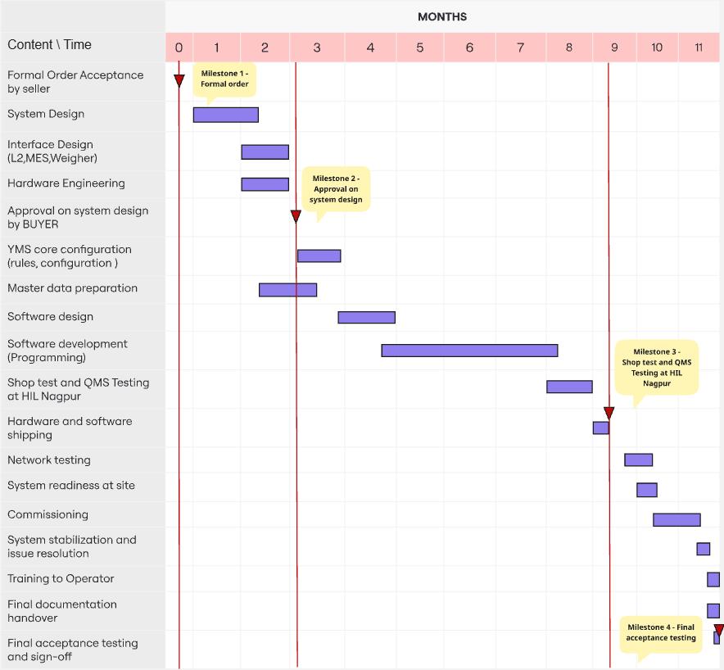
OVERALL SCHEDULE INDICATIVE FOR REFERENCE ONLY
Note: After Approval on System Design Document SELLER will take 4 Months for Software development. In the event of a delay in System design document approvals from the Customer, it will lead to an overall delay in the delivery. Above delivery schedule is for PMYMS application

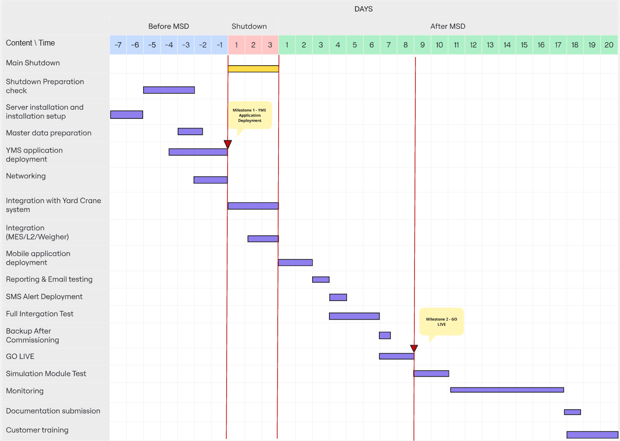
SHUTDOWN SCHEDULE INDICATIVE FOR REFERENCE ONLY
NOTE:
PMYMS Application Deployment & commissioning is subject to availability of the cranes from BUYER. The above shutdown schedule provided is for reference only. The final shutdown schedule will be determined through discussion and mutual agreement between the BUYER & SELLER

SUPERVISORS:
The following site-supervisor will be deputed to the site for the commissioning, deployment & training at site:
- Project Manager: 30 Days
- PMYMS Developer: 30 Days
- Commissioning SV (QA SV): 30 Days

Total 90 man-days (Inclusive of on-site training).


SCOPE OF SUPPLY

SCOPE OF SUPPLY DEFINITIONS

The engineering and software development service necessary for the proposed Yard Management System shall be provided either by BUYER or by the SELLER in accordance with the Scope of supply List. The matters not described in the said list shall be determined through mutual discussion.

BUYER : JSPL (B: BUYER)

SELLER : Hitachi India Pvt Ltd (S: SELLER)

BD : Basic Data
BE : Basic Engineering
DD : Detail Design
SU : Supply or Service
ER : Erection
COM : Commissioning

X/Y: Primary Work/Services provided by X with Support from Y

DIVISION OF ENGINEERING, SOFTWARE DEVELOPMENT, & ERECTION/COMMISSIONING SERVICES
No. | ITEM | Responsibility
 |  | BD | BE | DD | SU | ER | COM
(1) | Services
-1 | Project Execution | B/S | B/S | B/S | - | - | -
-2 | Overall system design | S | S/B | S/B | - | - | -
-3 | Work Test and Simulation | S | S | S | - | - | -
(2) | SYSTEM Engineering
-1 | Documentation | S | S | S | S | - | -
(3) | HARDWARE
-1 | PMYMS Server | S | S | S | S | B | S
-2 | PMYMS Client PC | S | S | S | S | B | S
-3 | Application Servers Console and Accessories | S | S | S | S | B | S
-4 | GSM Modem | S | S | S | S | B | S
-5 | HX Controller (For Unified Gateway) | S | S | S | S | B | S
-6 | Network Cables | B | B | B | B | B | B
-7 | Android Mobile Devices | B | B | B | B | B | B
(4) | SOFTWARE
-1 | Windows Server 2022 (64 bit) (5 CAL) | S | S | S | S |  | S
-2 | Microsoft Office 2021 | S | S | S | S |  | S
-3 | Microsoft Windows 11 Pro | S | S | S | S |  | S
-4 | Backup software | S | S | S | S |  | S
-5 | Python | S | S | S | S |  | S
-6 | Django | S | S | S | S |  | S
-7 | Angular Framework | S | S | S | S |  | S
-8 | Docker | S | S | S | S |  | S
-9 | MS SQL Server 2022 Standard Edition | S | S | S | S |  | S
-10 | Trend Micro Antivirus | S | S | S | S |  | S
(5) | TRAINING
-1 | PMYMS Training (Max 3 days) 5 persons | S | S | S | S | - | -
(6) | Pre-Engineering Activities
-1 | Study of Existing system | B/S | B/S | S | S | - | -
(7) | Documents to be submitted for Reference & Records
-1 | Screen Design Documents | S | S | S | S | - | -
-2 | Hardware Specifications | S | S | S | S | - | -
-3 | Software Specifications | S | S | S | S | - | -
-4 | PMYMS Operation Manual | S | S | S | S | - | -
(8) | Crane System
-1 | Position Sensors (X and Y Position) | S/B | S | S | B | S/B | S
-2 | Plate Lock/Unlock Sensor | S/B | S | S | B | S/B | S
-3 | Zeroing Sensor for Cranes | S/B | S | S | B | S/B | S
-4 | Wireless Transmitter Access Points | S/B | S | S | B | S/B | S
-5 | Wireless Receiver Access Points | S/B | S | S | B | S/B | S
-6 | Networking Accessories | S/B | S | S | B | S/B | S
-7 | Crane HMI (3 Nos.) | S/B | S | S | B | S/B | S
-8 | Gateway (1 No.) | S | S | S | B | S/B | S
-9 | Plate Mill L2 PMYMS  (Crane side sensors/devices/PLC modifications) | S/B | S | S | B | S | S
-10 | Plate Mill L2 PMYMS  (PMYMS side modifications) | S/B | S | S | B | S | S
(9) | Interface with Other System
-1 | Plate Mill L2 PMYMS  (L2 side modifications) | B | B | B | S | B | B
-2 | Plate Mill L2 PMYMS  (PMYMS side modifications) | S | S | S | S | S | S
-3 | Furnace L2 PMYMS  (L2 side modifications) | B | B | B | S | B | B
-4 | Furnace L2 PMYMS  (PMYMS side modifications) | S | S | S | S | S | S
-5 | Plate Mill L2 L3/SAP DB  (L3/SAP DB side modifications) | B | B | B | S | B | B
-6 | Plate Mill L2 L3/SAP DB  (PMYMS side modifications) | S | S | S | S | S | S
Note:
1) Any additional requirements beyond the scope mentioned above shall be discussed and mutually agreed upon. A separate proposal will be submitted for such additional requirements.
2) Firewall Configuration will be managed by BUYER.
3) PMYMS shall have interface with Level-2 system. Any data required from Level-1 system should be transferred from existing Level-1 system to existing Level-2 system like transfer car movement status etc.

VALUE ADDITION
The PMYMS system will be equipped with the following additional features:
1. SMS Gateway,
2. Unified Gateway
3. Customizable dashboard (For MIS)

WORK COMPLETION CERTIFICATE
Work Completion Criteria:
  - Supply of Hardware & Software as per the scope of supply (described in section 6.2)
  - Deployment of PMYMS
  - Submission of all documentation as per the scope (described in section 3.3)
  - Commissioning work Man-days used (as described in section 5.2)

Upon completion of the above criteria, the Work Completion Certificate will be issued by the BUYER to the SELLER, signifying the satisfactory completion of the project. The BUYER shall issue the Work Completion Certificate within seven (7) days of the completion of the above criteria. In case if the Work Completion Certificate is not issued by BUYER within this period, it is considered that Work Completion Certificate as deemed issued by the BUYER. If there are any issues/problems faced by BUYER, it will be mutually discussed, and SELLER would support BUYER with the best of the ability to resolve the issue.

By issuing the Work Completion Certificate, the BUYER acknowledges that the SELLER has fulfilled all contractual obligations and requirements.

BUYER OBLIGATIONS
The BUYER should fulfil the following obligations
        - Responsible for the project execution (answer technical queries in reasonable time and coordinate with all the stake holders of the project)
        - Arrange all the hardware in BUYER scope well ahead of the agreed time schedule.
        - Network cables & accessories not included in this technical proposal to be provided by BUYER
        - Site access to SELLER’s representative for data collection and discussion with the technical team as per requirement.
        - Dedicated internet connection
        - In case of any health issue to SELLER’s representative, BUYER to immediately provide best available medical facility. The expenses will be borne by the SELLER.
        - Provide complete and accurate master data (yard locations, material masters, product codes, QC codes, customer masters).
        - Arrange necessary network readiness (Wi-Fi coverage, VLAN configuration, IP releases, firewall rules, port openings).
        - Assign operations and crane operators for joint testing during commissioning. Make available weighbridge operators, yard supervisors, and QC personnel for integration testing.

EXCLUSION LIST
Only the services mentioned in the Scope of this are included. Any further services need to be mutually discussed, and commercial / technical implications discussed and compensated through a previously agreed change management mechanism.
Specific attention is drawn to the following services that are excluded from the scope of this technical proposal (unless specifically included elsewhere in this).
In this Technical proposal following are not included:
- Interface with external devices other than explicitly described in the technical proposal document.
- Software patches including but not limited to Microsoft Security updates, Antivirus updates or any other software upgrades or patches.
- Any warranty, guarantee, liability, responsibility, etc. about productivity, quality, yield, etc.
- Source code of software of core technology.
- Modifications to existing electrical and automation systems at PLATE MILL including but not limited to Level-1, Level-2, MES & FCE L1/L2 system.
- Software and hardware modifications in existing Crane PLC and Drive system, Crane control
- Erection activities wherever required for project execution. Any kind of Civil work.
- Hardware and software other than that is mentioned in technical document.
- Mechanical equipment supply, modification etc.
- Support for troubleshooting for mechanical/operation/process issues of customers.
- L2 & PDA software and related hardware
- Firewall and other networking components
- Performance with respect to productivity, yield, quality, process capability, process performance, etc.

BUYER PREREQUISITES:
- Readiness of the Crane System along with required hardware and Sensors
- Remote connection Set Up.
- Crane Availability in working condition.

BINDING CONDITIONS:
- SELLER scope of supply & services as described in agreed & signed technical specifications (TS) shall be limited, as per the input/information obtained from the BUYER, only to the modification/creation of interface program for helping the BUYER to use SELLER supplied equipment/items for obtaining the required functioning at BUYER own responsibility.
- All the services, except for those under the scope of SELLER as per the agreed & signed TS, will be under the full responsibility of BUYER. SELLER neither guarantees any performance nor SELLER is liable for any claims for the non-performance of such Equipment & services.
- SELLER scope of supply & services excludes any supervision, management, regulation, arbitration and/or measurement of BUYER's personnel, agents or contractors and work related thereto nor does include any responsibility for the scheduling, monitoring or management of their work.
- SELLER supervisors shall have the right to leave the site without any permission or approval of BUYER in the following cases:
- If the idling periods extend more than a considerable time as judged by SELLER.
- If the BUYER does not follow the conditions of the agreed terms as per the agreed and signed TS
- An act of God such as natural calamities, war, riot, rebellion, invasion, commotion, epidemics, terrorism, or such other phenomenon which is predictable to affect the body or life of our supervisors directly or indirectly.
- If BUYER prerequisites are not fulfilled as per the agreed and signed TS.
- Circumstances at project site are not conducive and are beyond SELLER’s control as judged by SELLER.
- SELLER will not be responsible for
- Performance guarantee of any kind.
- Productivity AND/OR Quality of the Product
- SELLER will not be responsible for any failed/missing/damaged equipment, item, and components etc. during the execution of the service work unless otherwise explicitly mentioned in the contract.
- Unless explicitly mentioned in the agreed and signed TS, SELLER will not take responsibility for any modification or updating of the existing system.
- Ensuring Normal working of existing servers/systems, L2 System, Crane System, Crane control, Crane instrumentations/sensors/devices and L1 system lies with BUYER.
- Responsibility of Firewall configuration and its proper working for Cyber Security aspects lies with BUYER.
- The effective date of execution of the contract shall be the PO acceptance date by the SELLER.
- Completion of scope of services of SELLER as per agreed and signed TS by virtue of receipt of Work Completion Certificate/Deemed Issued Work Completion Certificate by SELLER will be prerequisite condition to take up any new/additional scope of work for PLATE MILL, JSL.
- Responsibility and Liability for SELLER- Nil, except for the scope defined in this technical proposal document

CYBERSECURITY DISCLAIMER
SELLER strongly recommends that security updates are implemented by BUYER as soon as they are available and that the latest versions are used. Use of versions that are no longer supported, and failure to apply the latest updates may increase the exposure to cyber threats. This application contains confidential information. It is the sole responsibility of end-user to maintain confidentiality and proper usage of the information contained herein. The BUYER is responsible for preventing unauthorized access to the existing plant systems. The BUYER will be responsible for Cybersecurity, Information Security, Hardware Security, Personal Data Security, Overall Data security, Network security, equipment security. In no event shall SELLER be liable for any direct, indirect, incidental, consequential, or special damages arising out of or in connection with any cybersecurity incidents, data breaches, unauthorized access, or any other security-related events, regardless of the cause of action.


DISCLAIMER

SOFTWARE LICENSES
The use of the delivered software, or parts of the same, is strictly limited to the services provided. The BUYER has the right to use and modify the software for normal use and for the lifetime of the system supplied by SELLER. Any duplication (except for normal back-up purpose), distribution to third parties, sell or use in other plants is prohibited. It’s also prohibited to make software accessible to third parties. All rights of the software remain with SELLER.
‘BUYER is responsible for maintaining and ensuring valid license for use of third-party software and legal use of third-party software used in this system. In no event shall SELLER be liable for any issue or claim or damage arising out of use of any third-party software.’

CHANGES DUE TO TECHNICAL IMPROVEMENTS
SELLER follows a policy of continuous improvement of design, manufacturing and software development and therefore reserves the right to supply systems differing in detail from what is described in this document.

CONFIDENTIALITY OF INFORMATION (Non-Disclosure Agreement)
According to the law, SELLER considered this document to be a company secret and therefore prohibits any person to reproduce or disclose it in whole or part to third parties, without specific written authorization of SELLER Management.

LIMITATION OF LIABILITY & CONSEQUENTIAL DAMAGES
With respect to any and all liability of SELLER out of or in connection with this Technical proposal notwithstanding anything contained herein to the contrary in no event shall SELLER’s total liability for any and all claims, damages or liabilities arising out of related to its performance of this Technical proposal, including but not limited to any liquidated damages, costs for repairs, replacement, rectifications of defects, dismantling, etc., exceed one hundred percent (100%) of the SELLER’s Contract Price. In no event shall SELLER be liable for any indirect or consequential damages, including but not limited to any loss of profit, loss of use, loss of Contracts, loss of production or business interruption. According to law, SELLER considers this document to be a company secret and therefore prohibits any person to reproduce or disclose it in whole or part to third parties, without specific written authorization of SELLER Management


COMPLIMENTRY PROOF OF CONCEPTS (PoC)
SELLER is pleased to provide complimentary Proof of Concept (PoC) along with the afore-mentioned system to showcase SELLER’s latest offerings in Composite Automation & Digital Solutions (CADS) & Digital Transformation (DX) Solutions. The PoC will be conducted on the same server.
The solutions under the PoC will be deployed for a limited period of two months to demonstrate the capabilities of these solutions. Upon successful completion of the demonstration, the BUYER must capitalize on the benefits by purchasing these solutions through a separate commercial contract, ensuring continued access to their full potential. The SELLER reserves the right to withdraw the PoC solutions if the BUYER does not proceed with the purchase following the demonstration.

The following solution will be part of the PoC:

  - AUTOML PLATFORM
To drive Digital Transformation (DX) in the existing setup, SELLER is pleased to propose the deployment of an “AutoML Platform” on an existing server/PC (to be provided by BUYER) for a limited period as a Proof of Concept (PoC).
The objective of this engagement is to demonstrate the platform’s ability to accelerate data-driven insights, streamline model development, and enhance decision-making capabilities without extensive manual intervention.
•The AutoML platform will be installed and configured on the BUYER supplied server/PC infrastructure.
• The PoC will run for a limited duration solely for demonstration purposes.
• The platform will enable:
a. Automated data preprocessing, feature engineering, and model selection.
b. Model evaluation, and performance benchmarking.
c. Hyperparameter Tuning
d. Demonstration of at least two ML Model working through predictive and prescriptive insights.
The PoC will be carried out solely for demonstration and evaluation purposes. It will cover only the essential functionalities required to highlight the AutoML platform’s efficiency and user-friendly automation capabilities. The SELLER will install and configure the platform on the BUYER’s infrastructure and enable the core modules necessary to process and analyse a limited dataset (not more than 50MB size). The exercise will involve a demonstration of model training and evaluation using sample or BUYER- provided data, with results presented in the form of performance reports and interpretability outputs.
To maintain a focused and time-bound implementation, certain elements are excluded from this PoC. These include integration with the BUYER’s other production systems, large-scale data ingestion, real-time model deployment, or automation through APIs. Advanced capabilities such as user management, security governance, and scalability testing will also fall outside the initial PoC scope. However, the full version of the AutoML platform offers such extensive functionality that can be availed by BUYER by purchasing the solution through a separate commercial contract
FOR REFERENCE
HIL CONFIDENTIAL
FOR REFERENCE
HIL CONFIDENTIAL
Fig: AutoML Platform Reference Screenshot

End of Technical Proposal

